Exim Bank Management Trainee

1. IT Infrastructure & Architecture: Understanding of overall Computer Architecture including data center and technology setup in banks/ financial institutions. Management of hardware, software, and network infrastructure

* <https://www.ibm.com/think/topics/infrastructure>
* <https://www.redhat.com/en/topics/cloud-computing/what-is-it-infrastructure>

1. Operating systems:

* <https://www.tutorialspoint.com/operating_system/index.htm>
* <https://www.ccbp.in/blog/articles/services-of-operating-system>

1. Database Management Systems (DBMS): Understanding of Oracle/SQL databases & concepts including query writing, procedure, cursor, package & triggers.
2. Computer Networks: Networking fundamentals, TCP/IP model, IP addressing, and network protocols

* <https://www.ibm.com/think/topics/networking>
* <https://www.tpointtech.com/computer-network-tcp-ip-model>
* <https://scalac.io/blog/networking-basics/>
* <https://www.tutorialspoint.com/communication_technologies/communication_technologies_network_protocols.htm>

1. Cryptography: Encryption, decryption, hashing, and security protocols.

* <https://www.fortinet.com/resources/cyberglossary/what-is-cryptography#:~:text=Hash%20Function,the%20hash%20or%20hash%20value>
* <https://jdewapura.medium.com/security-1-encryption-decryption-vs-hashing-f0172134a73a>
* <https://www.ssl.com/article/what-is-a-cryptographic-protocol/>

1. Object-Oriented Programming (OOP): Concepts like classes, inheritance, polymorphism, and abstraction.

* [Introduction of Object Oriented Programming | GeeksforGeeks](https://www.geeksforgeeks.org/introduction-of-object-oriented-programming/)
* <https://www.nerd.vision/post/polymorphism-encapsulation-data-abstraction-and-inheritance-in-object-oriented-programming>

1. Software Development Life Cycle (SDLC): Understanding of SDLC including Waterfall, Agile, and other methodologies

* <https://aws.amazon.com/what-is/sdlc/>
* <https://www.ibm.com/think/topics/sdlc>
* <https://www.virtasant.com/blog/sdlc-methodologies>
* <https://www.techtarget.com/searchsoftwarequality/tip/Waterfall-vs-Agile-methodology-Differences-and-examples>

1. Version Control and Dev-Sec-Ops: Git and other tools for collaborative software development including devops/ micro services/ build and test automation/ dynamic and static security analysis.

* <https://aws.amazon.com/what-is/devsecops/>
* <https://testautomationu.applitools.com/test-automation-in-devops/>
* <https://www.harness.io/blog/static-vs-dynamic-code-analysis>

1. Network Security: Basic understanding about network protocols including Firewalls, intrusion detection and prevention systems, and VPNs

* <https://www.fortinet.com/resources/cyberglossary/what-is-network-security>

1. Data Security:

* Encryption:
* Definition: Encryption is the process of translating plain test data(plaintext) into something that appears to be random and meaningless(ciphertext).
* It is the process of transforming information in a way that, ideally, only authorized parties can decode it.
* We done this to secure data from threads, cybercrime, used to prevent unauthorized access.
* It can be applied to documents, files, messages or any other form of communication over a network.
* How does data encryption work: The data that needs to be encrypted is termed as plaintext or cleartext. The plaintext needs to be passed via some encryption algorithms, which are basically mathematical calculations to be done on raw information. There are multiple encryption algorithms, each of which differs by application and security index.
* Types:

1. Symmetric Encryption: Same key used for encryption and decryption

Type: Advanced Encryption Standard (AES) and the Data Encryption Standard (DES)

In this approach, the key used to secure the data must be shared between the entities involved in communication.

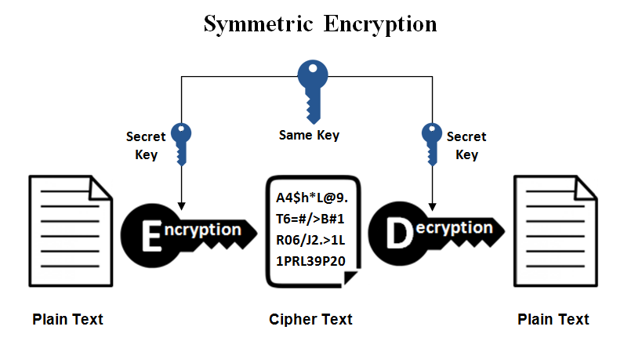

1. Asymmetric encryption: A pair of keys- Public key used for encryption, private key for decryption.

The public key can be openly distributed, allowing anyone to encrypt messages, while the private key must be kept confidential for decrypting the received messages.

used for secure key exchange, ensuring a confidential communication channel, and for implementing digital signatures.

Type: RSA (Rivest-Shamir-Adleman) and Elliptic Curve Cryptography (ECC)

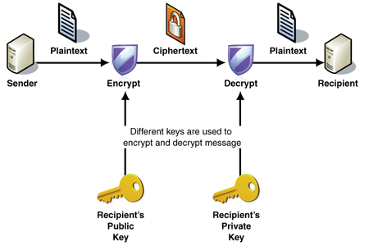

* In Banking: Encrypting sensitive data like customer account info, transactions, or passwords. Used in SSL/TLS for secure web traffic (e.g., HTTPS). End-to-end encryption in mobile banking apps.
* Decryption: is the process of converting ciphertext back to plaintext.
* 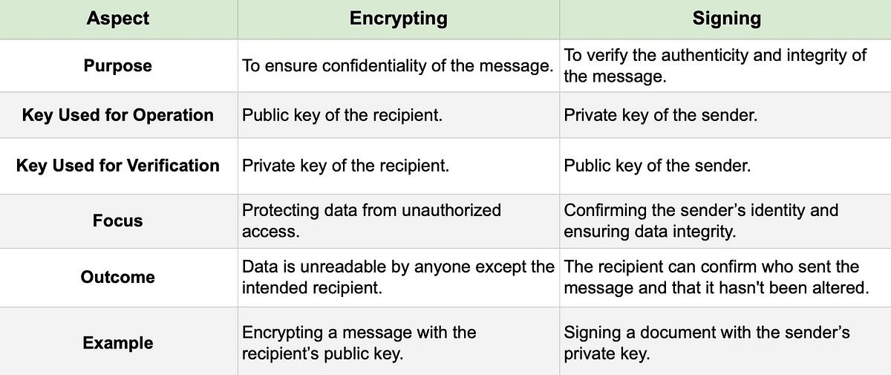
* Access control: Controlling who can access what resources.
* Definition: It is a data security process that enables organizations to manage who is authorized to access corporate data and resources. Secure access control uses policies that verify users are who they claim to be and ensures appropriate control access levels are granted to users.
* ensures only the right users have the right level of access to the right resources .
* It Helps organization to avoid data breaches and fighting attack vectors, such as a buffer overflow attack, KRACK attack, on-path attack, or phishing attack.
* Components of Access Control:

1. Authentication
2. Authorization
3. Access
4. Manage
5. Audit

* <https://www.fortinet.com/resources/cyberglossary/access-control#:~:text=Access%20control%20is%20a%20data,levels%20are%20granted%20to%20users>.
* 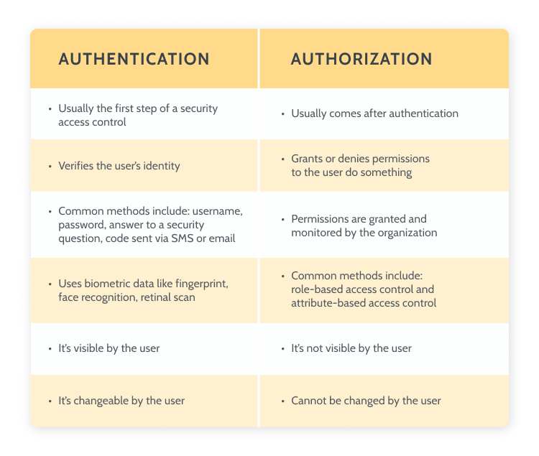
* Data protection
* <https://www.techtarget.com/searchdatabackup/definition/data-protection>

1. Security Threats and Vulnerabilities: Understanding common attacks and prevention measures, OWASP Top 10

* <https://www.cloudflare.com/learning/security/threats/owasp-top-10/>
* <https://www.aquasec.com/cloud-native-academy/cloud-attacks/top-10-cyber-security-threats/>

1. Project Management:

* <https://kissflow.com/project/five-phases-of-project-management/>
* <https://www.atlassian.com/work-management/project-management/it-project-management>

1. Problem solving and analytical skills:

* <https://arc.dev/talent-blog/analytical-skills/>
* <https://trainingexpress.org.uk/7-steps-to-improve-your-problem-solving-skills/>

1. Cloud Computing:

* <https://aws.amazon.com/what-is-cloud-computing/>
* <https://www.jaroeducation.com/blog/types-of-cloud-services-and-deployment-models/>

1. Business Intelligence (BI): Business strategies and technologies to analyze data for informed data-driven business decisions.

* Aims to bring the business and data together, Data sourcing and management, ETL( Extract, transform and load), Visualizations and dashboards, Data quality and governance, Data security and privacy, Data and Business roles

Tools and Techniques for Data Visualization and Reporting:

* Provides Insights about data like Understand why sales are increasing in a certain region, Identify when there will be excess inventory, what is customer sentiment towards the company
* Taking data to intelligence : Business analytics-> Data Mining -> Data visualization-> Data Management
* Consists :
* Data Analysis:
* Data Management and warehousing
* Data Transformation
* Big data
* Reporting and dashboards
* Online Analytical processing (OLAP)
* Data and process mining
* Benchmarking
* Predictive and prescriptive analytics
* Technology for BI:
* 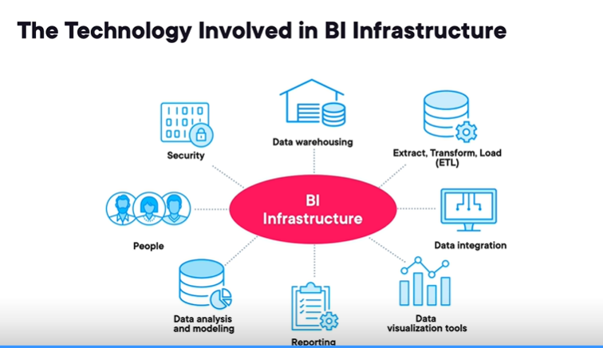
* Data Visualization tools:
* Interactive dashboards
* Customizable templates
* BI Elements :
* Data
* People
* Processes
* Technology
* 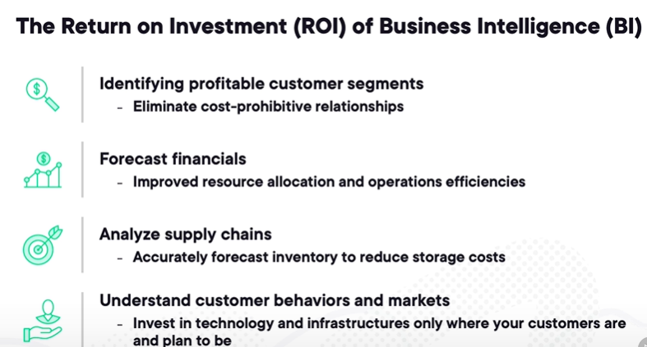

1. Data Science:

* <https://aristeksystems.com/blog/basics-of-ai-data-science-ml-deep-learning-and-generative-ai/#:~:text=It%20encompasses%20data%20science%2C%20which,cases%2C%20and%20other%20essential%20insights%3F>
* <http://guvi.in/blog/data-science-tools/>
* <https://www.datacamp.com/blog/what-is-data-science-the-definitive-guide>
* <https://aws.amazon.com/compare/the-difference-between-data-science-and-ai/>